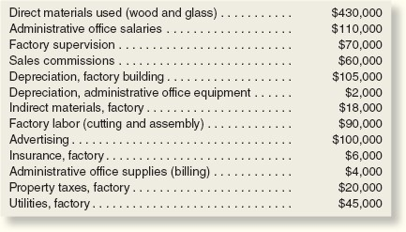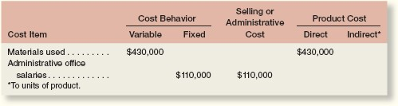

PROBLEM 2–24 Cost Classification and Cost Behavior

Heritage Company manufactures a beautiful bookcase that enjoys widespread popularity. The company
has a backlog of orders that is large enough to keep production going indefinitely at the plant's full
capacity of 4,000 bookcases per year. Annual cost data at full capacity follow:
Page 62

Required:

1
. Prepare an answer sheet with the column headings shown below. Enter each cost item on your
answer sheet, placing the dollar amount under the appropriate headings. As examples, this has
been done already for the first two items in the list above. Note that each cost item is classified in
two ways: first, as either variable or fixed with respect to the number of units produced and sold; and
second, as either a selling and administrative cost or a product cost. (If the item is a product cost, it
should also be classified as either direct or indirect as shown.)

- Total the dollar amounts in each of the columns in (1) above. Compute the average product cost per bookcase.
- Due to a recession, assume that production drops to only 2,000 bookcases per year. Would you expect the average product cost per bookcase to increase, decrease, or remain unchanged? Explain. No computations are necessary.
- Refer to the original data. The president's next-door neighbor has considered making himself a bookcase and has priced the necessary materials at a building supply store. He has asked the president whether he could purchase a bookcase from the Heritage Company “at cost,” and the president has agreed to let him do so.
  - Would you expect any disagreement between the two men over the price the neighbor should pay? Explain. What price does the president probably have in mind? The neighbor?
  - Because the company is operating at full capacity, what cost term used in the chapter might be justification for the president to charge the full, regular price to the neighbor and still be selling “at cost”? Explain.

